My Career

APPLIED PROJECT AND MINOR dissertation

Alexander Souza – G00317835

Supervisor

Damien Costello

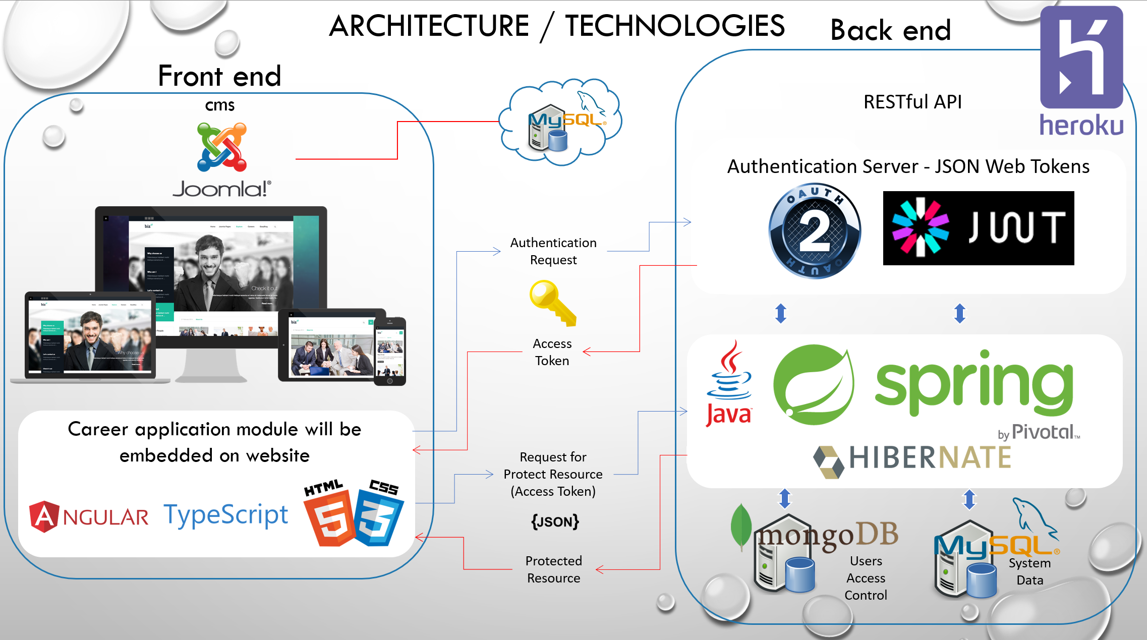

## GitHub

# <https://github.com/alexpt2000gmit/4Year_MainProject_MyCareer>

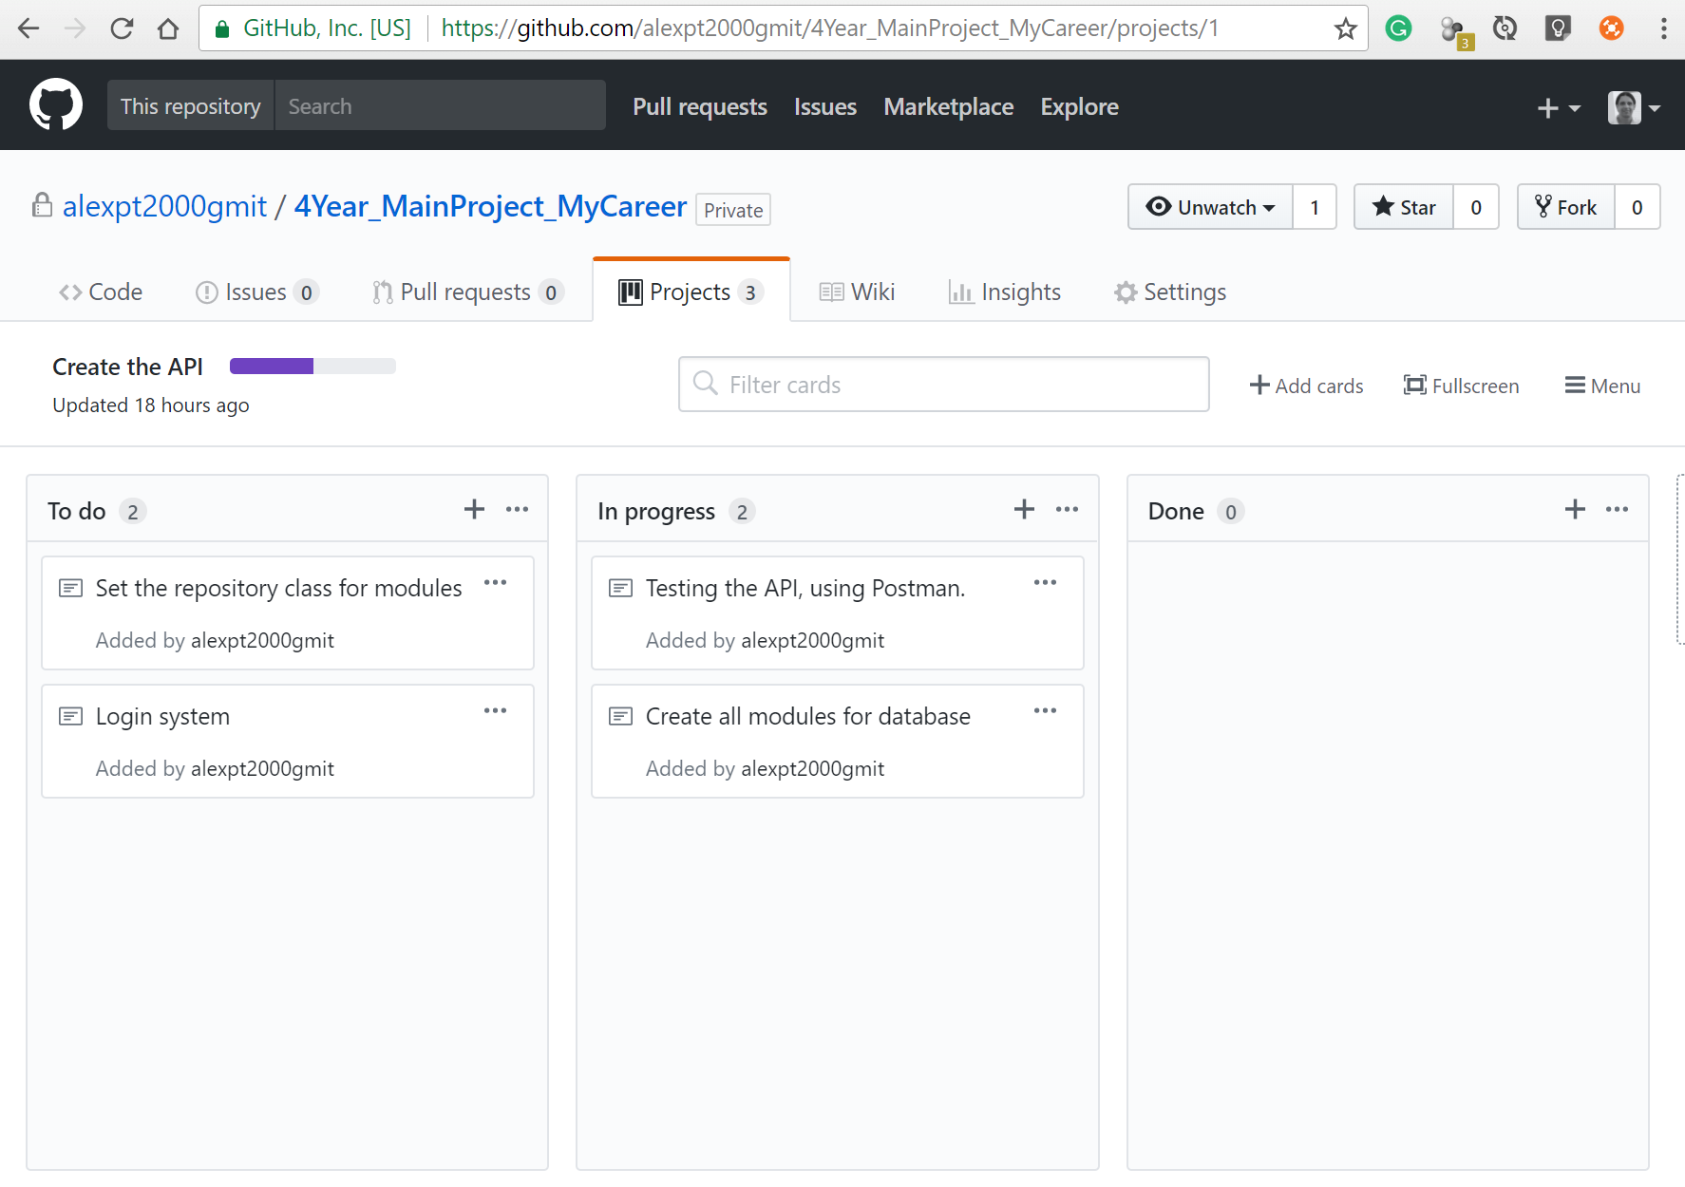

* Database – Using Access to design and MySQL to storage

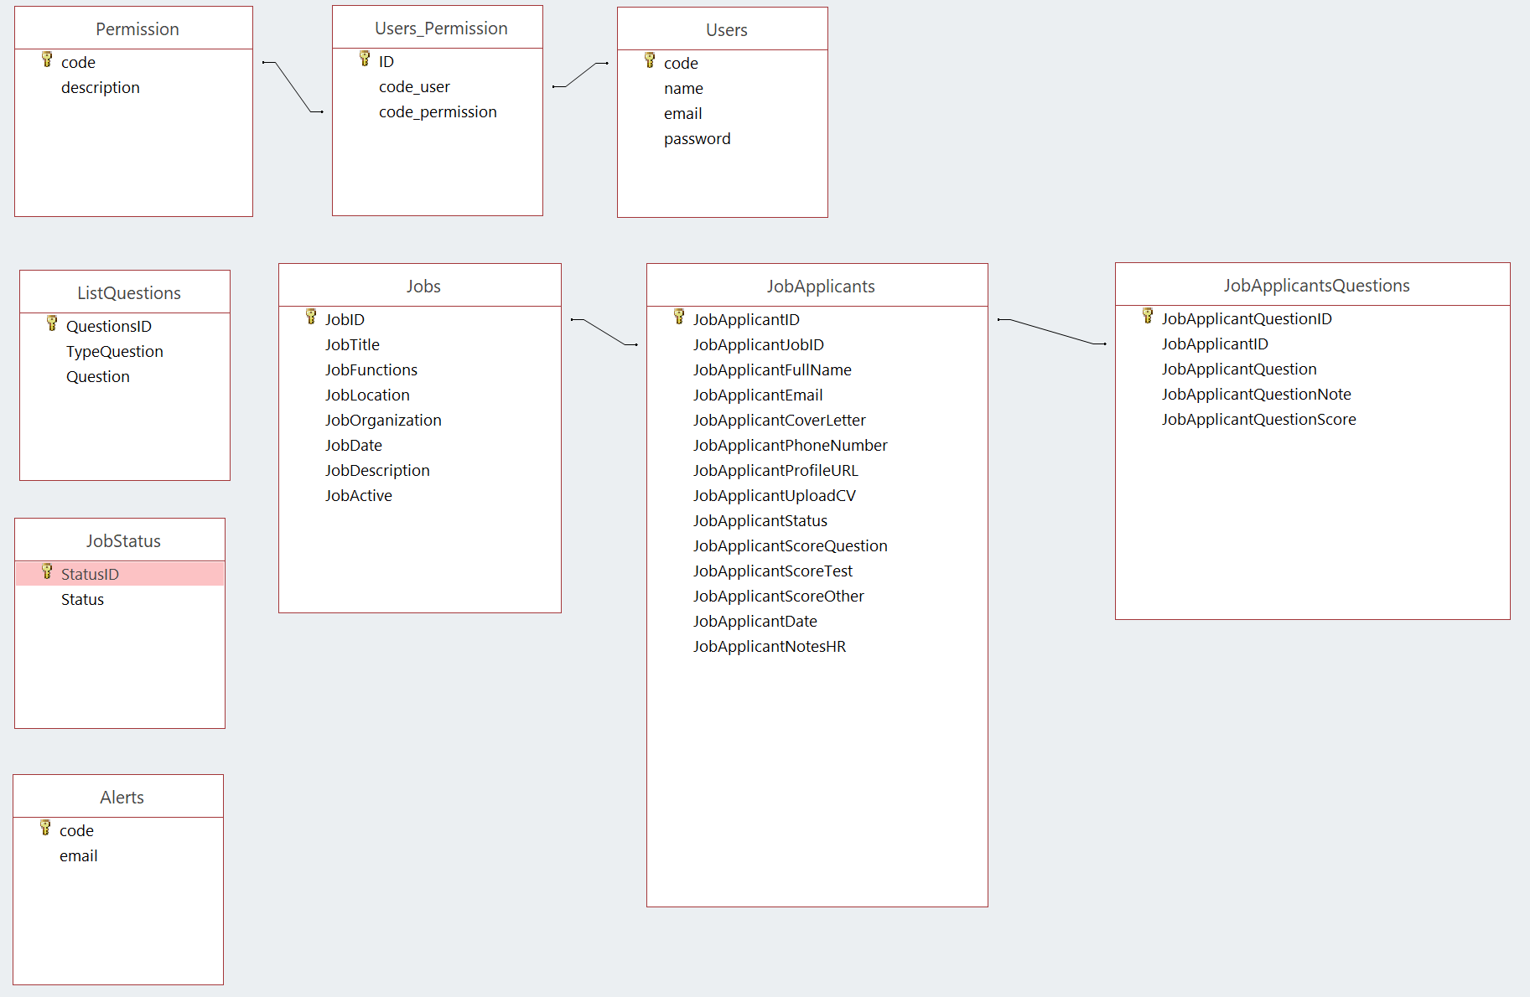

* Web site – on AWS
  + <http://54.210.4.37/mycareer/>
* Template back-end
  + <https://www.primefaces.org/omega-ng/#/>
* UI library
  + <https://www.primefaces.org/primeng/#/>
* RESTfull API – Spring

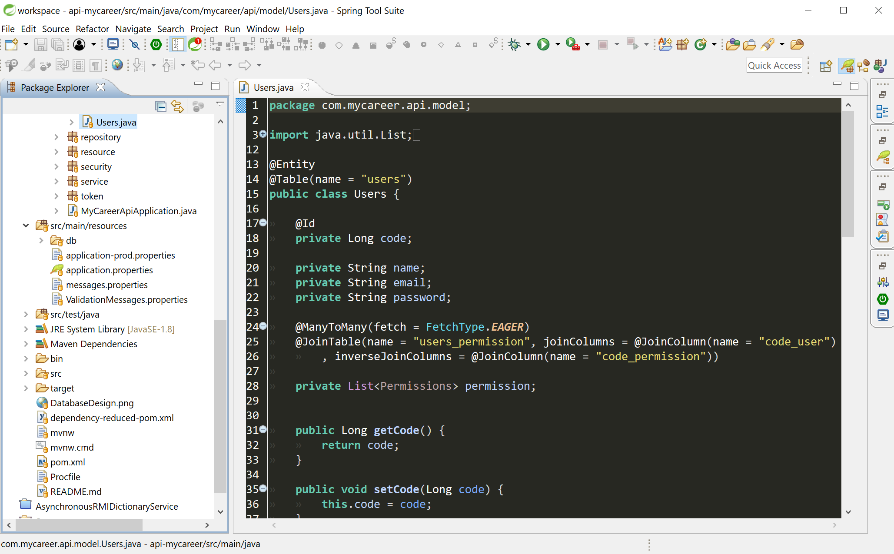

* Testing API – Postman

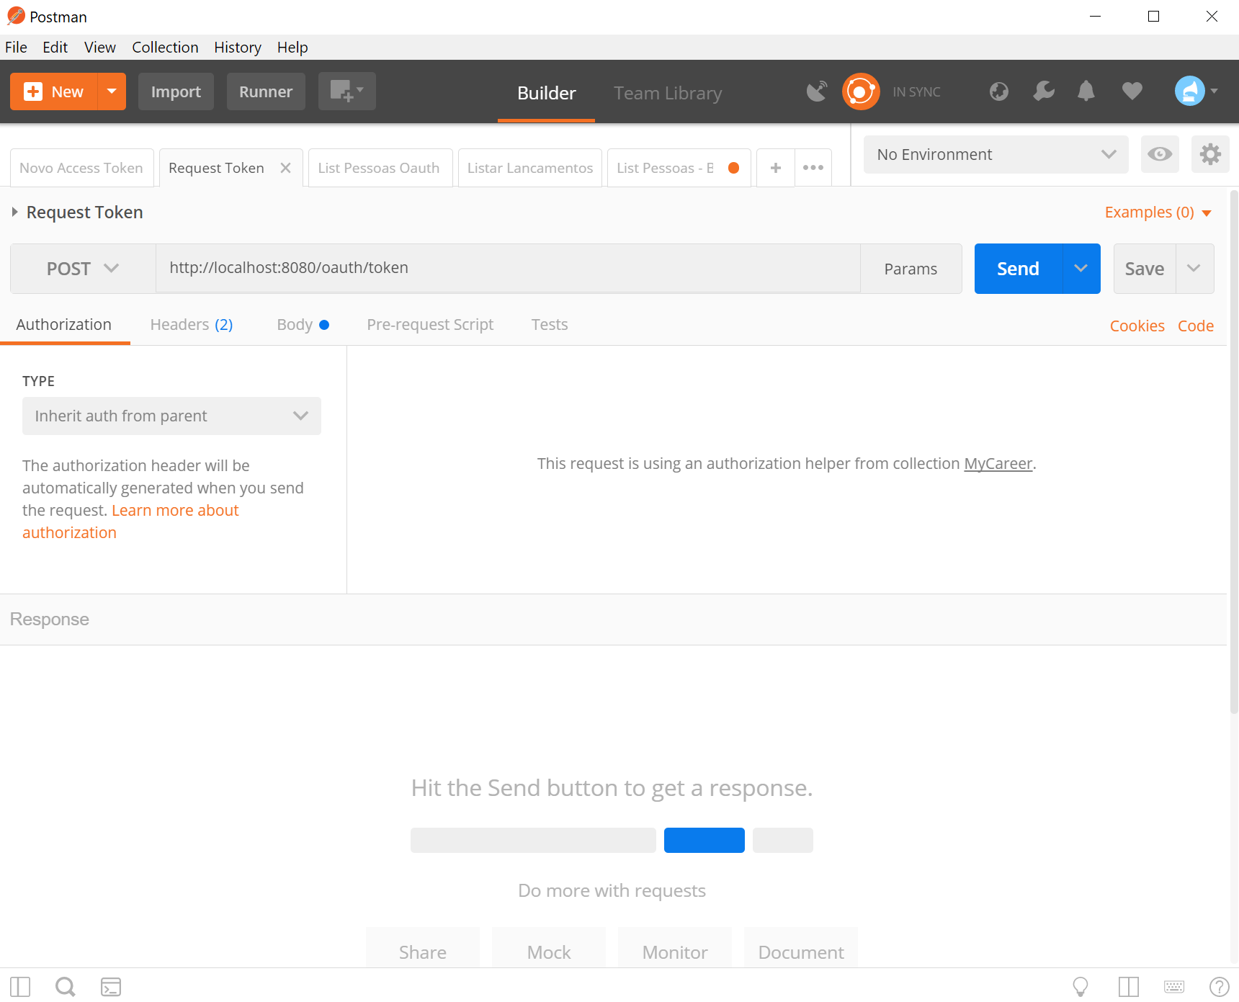

* [Base64 Decode and Encode](https://www.google.ie/url?sa=t&rct=j&q=&esrc=s&source=web&cd=1&ved=0ahUKEwi55PvK--3YAhXJCcAKHWcVDFAQFggpMAA&url=https%3A%2F%2Fwww.base64encode.org%2F&usg=AOvVaw0Rj8bzcSNYEqZ7lDq2Pu0C)
  + <https://www.base64encode.org/>
* [Flyway - Database Java Migration](http://www.methodsandtools.com/tools/flyway.php)
  + <https://flywaydb.org/>